EXPERIMENT 2
EXPLORATORY DATA ANALYSIS (EDA) – DATA IMPORT AND EXPORT USING CREDIT CARD FRAUD DATASET
Aim
To import the Credit Card Fraud Detection dataset from Excel and CSV files, perform basic inspection and analysis using Pandas, and export the processed data into different file formats.
Algorithm 1: Importing CSV File
Step 1:
Import the Pandas and NumPy libraries.
Step 2:
Load the Credit Card Fraud Detection CSV file using read_csv().
Step 3:
Display the first few records.
Step 4:
Check the structure and data types of the dataset.
Step 5:
Analyze the imported data using basic statistical functions.
Program:

import pandas as pd
import numpy as np
df = pd.read_excel("C:/Users/palan/Downloads/credit_card_fraud.xlsx")
print(df.head())

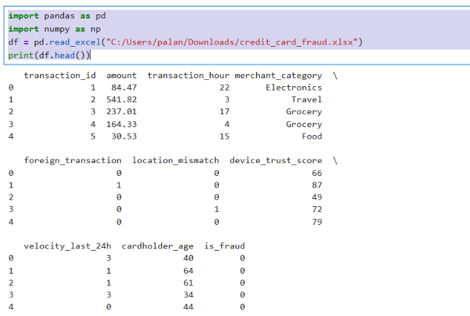

print(df.info())
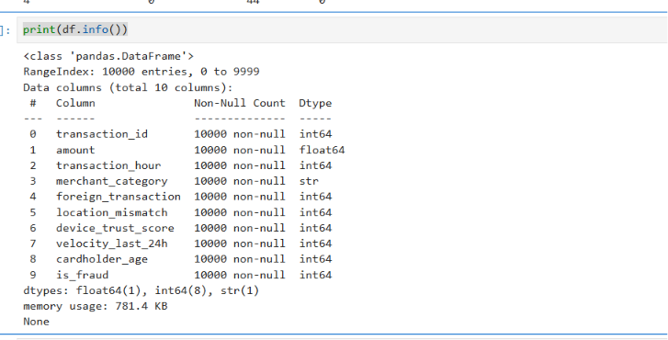

print(df.isnull().sum())
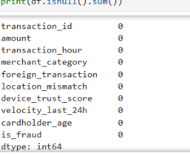

print(df.duplicated().sum())

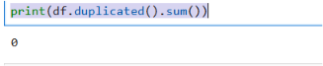

print(df.columns)

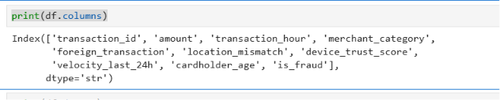

print(df.isnull().sum())

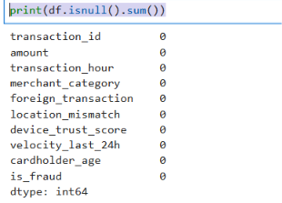

print(df.dtypes)

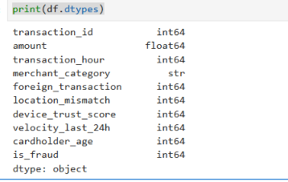

df.to_csv("C:/Users/palan/Downloads/credit_card_fraud_output.csv", index=False)

print("Data exported successfully to CSV")

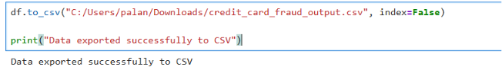

df.to_excel("C:/Users/palan/Downloads/credit_card_fraud_output.xlsx", index=False)

print("Data exported successfully to Excel")
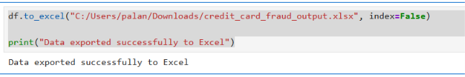

import sqlite3
import pandas as pd

# Connect to SQLite database
conn = sqlite3.connect("credit_card_fraud.db")

# Create table
cursor = conn.cursor()

cursor.execute("""
CREATE TABLE IF NOT EXISTS transactions (
transaction_id INTEGER,
amount REAL,
transaction_hour INTEGER,
merchant_category TEXT,
foreign_transaction INTEGER,
location_mismatch INTEGER,
device_trust_score REAL,
velocity_last_24h INTEGER,
cardholder_age INTEGER,
is_fraud INTEGER
)
""")

# Insert data from the Excel dataset
data = pd.read_excel(
"C:/Users/palan/Downloads/credit_card_fraud.xlsx"
)

data.to_sql(
"transactions",
conn,
if_exists="replace",
index=False
)

# Retrieve records using SQL query
query = "SELECT * FROM transactions"

df = pd.read_sql(query, conn)

print(df.head())

conn.close()
